**POKHARA UNIVERSITY (PU)**

**A MINOR PROJECT OF A NEWARI KITCHEN**

**Bachelor in Computer System and Information Technology (BCSIT)**



**MEDHAVI COLLEGE**

Sankhamul, New Baneshwor, Kathmandu

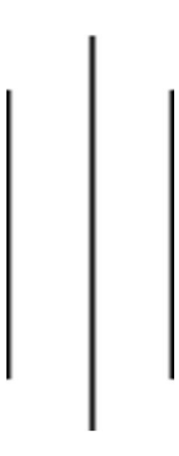

Submitted By: Submitted To:

Prayush Hada [23100186] Niranjan Sir

Krijala Shrestha [23100172]

Upama Shrestha [23100202]